**PLEASE BRING THESE ITEMS IN A ZIPLOC BAG LABELED WITH YOUR CHILD’S NAME ON THE FIRST DAY OF SCHOOL**

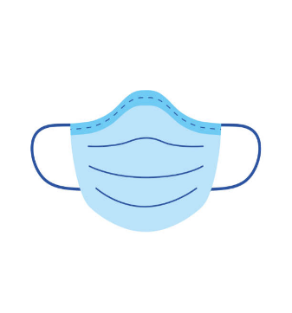COTTON MASK

EACH CHILD MUST HAVE THEIR OWN MASK LABELED WITH THEIR NAME

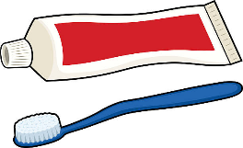

TOOTHBRUSH WITH CAP &

TOOTHPASTE

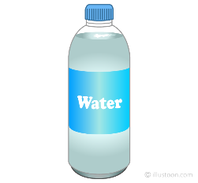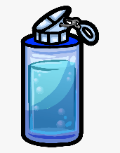**BRING THE FOLLOWING ITEMS IN A ZIPLOC BAG**

BOTTLE OF WATER,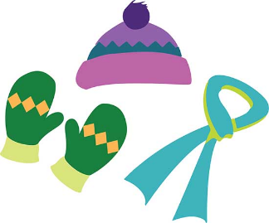 THERMOS,

½ GALLON OF MILK IF CHILD HAS AN ALLERGEY

COMPLETE SETS OF CLOTHES FOR WINTER

INCLUDING WOOL HAT, SCARF, GLOVES, UNDERWEAR,

SOCKS, SNEAKERS AND WIPES

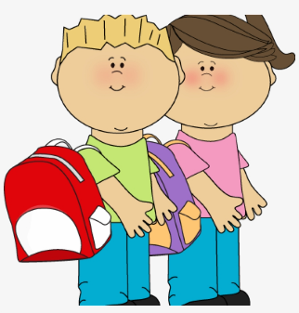

SHEETS, BLANKET AND

SMALL PILLOW

SMALL BACKPACK FOR SHEETS,

BLANKETS AND EXTRA CLOTHES

**PLEASE KEEP IN MIND THAT BLANKETS AND SHEETS MUST GO HOME **DAILY** AND MUST BE RETURNED TO SCHOOL THE **NEXT DAY**\*\*